Train 100 epochs optimizer,model=yolov9s.pt,
Ultralytics 8.3.102 🚀 Python-3.11.11 torch-2.6.0+cu124 CUDA:0 (NVIDIA L4, 22693MiB)
engine/trainer: task=detect, mode=train, model=yolov9s.pt, data=dataset/fixed_path.yaml, epochs=100, time=None, patience=100, batch=4, imgsz=640, save=True, save_period=-1, cache=False, device=None, workers=8, project=None, name=train3, exist_ok=False, pretrained=True, optimizer=auto, verbose=True, seed=0, deterministic=True, single_cls=False, rect=False, cos_lr=False, close_mosaic=10, resume=False, amp=True, fraction=1.0, profile=False, freeze=None, multi_scale=False, overlap_mask=True, mask_ratio=4, dropout=0.0, val=True, split=val, save_json=False, save_hybrid=False, conf=None, iou=0.7, max_det=300, half=False, dnn=False, plots=True, source=None, vid_stride=1, stream_buffer=False, visualize=False, augment=False, agnostic_nms=False, classes=None, retina_masks=False, embed=None, show=False, save_frames=False, save_txt=False, save_conf=False, save_crop=False, show_labels=True, show_conf=True, show_boxes=True, line_width=None, format=torchscript, keras=False, optimize=False, int8=False, dynamic=False, simplify=True, opset=None, workspace=None, nms=False, lr0=0.01, lrf=0.01, momentum=0.937, weight_decay=0.0005, warmup_epochs=3.0, warmup_momentum=0.8, warmup_bias_lr=0.1, box=7.5, cls=0.5, dfl=1.5, pose=12.0, kobj=1.0, nbs=64, hsv_h=0.015, hsv_s=0.7, hsv_v=0.4, degrees=0.0, translate=0.1, scale=0.5, shear=0.0, perspective=0.0, flipud=0.0, fliplr=0.5, bgr=0.0, mosaic=1.0, mixup=0.0, copy_paste=0.0, copy_paste_mode=flip, auto_augment=randaugment, erasing=0.4, crop_fraction=1.0, cfg=None, tracker=botsort.yaml, save_dir=runs/detect/train3
Downloading https://ultralytics.com/assets/Arial.ttf to '/root/.config/Ultralytics/Arial.ttf'...
100%|██████████| 755k/755k [00:00<00:00, 25.2MB/s]
Overriding model.yaml nc=80 with nc=2

from n params module arguments
0 -1 1 928 ultralytics.nn.modules.conv.Conv [3, 32, 3, 2]
1 -1 1 18560 ultralytics.nn.modules.conv.Conv [32, 64, 3, 2]
2 -1 1 31104 ultralytics.nn.modules.block.ELAN1 [64, 64, 64, 32]
3 -1 1 73984 ultralytics.nn.modules.block.AConv [64, 128]
4 -1 1 258432 ultralytics.nn.modules.block.RepNCSPELAN4 [128, 128, 128, 64, 3]
5 -1 1 221568 ultralytics.nn.modules.block.AConv [128, 192]
6 -1 1 579648 ultralytics.nn.modules.block.RepNCSPELAN4 [192, 192, 192, 96, 3]
7 -1 1 442880 ultralytics.nn.modules.block.AConv [192, 256]
8 -1 1 1028864 ultralytics.nn.modules.block.RepNCSPELAN4 [256, 256, 256, 128, 3]
9 -1 1 164608 ultralytics.nn.modules.block.SPPELAN [256, 256, 128]
10 -1 1 0 torch.nn.modules.upsampling.Upsample [None, 2, 'nearest']
11 [-1, 6] 1 0 ultralytics.nn.modules.conv.Concat [1]
12 -1 1 628800 ultralytics.nn.modules.block.RepNCSPELAN4 [448, 192, 192, 96, 3]
13 -1 1 0 torch.nn.modules.upsampling.Upsample [None, 2, 'nearest']
14 [-1, 4] 1 0 ultralytics.nn.modules.conv.Concat [1]
15 -1 1 283008 ultralytics.nn.modules.block.RepNCSPELAN4 [320, 128, 128, 64, 3]
16 -1 1 110784 ultralytics.nn.modules.block.AConv [128, 96]
17 [-1, 12] 1 0 ultralytics.nn.modules.conv.Concat [1]
18 -1 1 598080 ultralytics.nn.modules.block.RepNCSPELAN4 [288, 192, 192, 96, 3]
19 -1 1 221440 ultralytics.nn.modules.block.AConv [192, 128]
20 [-1, 9] 1 0 ultralytics.nn.modules.conv.Concat [1]
21 -1 1 1061632 ultralytics.nn.modules.block.RepNCSPELAN4 [384, 256, 256, 128, 3]
22 [15, 18, 21] 1 1563862 ultralytics.nn.modules.head.Detect [2, [128, 192, 256]]
YOLOv9s summary: 544 layers, 7,288,182 parameters, 7,288,166 gradients, 27.4 GFLOPs

Transferred 1333/1339 items from pretrained weights
TensorBoard: Start with 'tensorboard --logdir runs/detect/train3', view at http://localhost:6006/
Freezing layer 'model.22.dfl.conv.weight'
AMP: running Automatic Mixed Precision (AMP) checks...
Downloading https://github.com/ultralytics/assets/releases/download/v8.3.0/yolo11n.pt to 'yolo11n.pt'...
100%|██████████| 5.35M/5.35M [00:00<00:00, 106MB/s]
AMP: checks passed ✅
train: Scanning /content/drive/MyDrive/brain_tumor_dataset/dataset/labels/train... 703 images, 0 backgrounds, 0 corrupt: 100%|██████████| 703/703 [00:05<00:00, 136.13it/s]
train: New cache created: /content/drive/MyDrive/brain_tumor_dataset/dataset/labels/train.cache
albumentations: Blur(p=0.01, blur_limit=(3, 7)), MedianBlur(p=0.01, blur_limit=(3, 7)), ToGray(p=0.01, num_output_channels=3, method='weighted_average'), CLAHE(p=0.01, clip_limit=(1.0, 4.0), tile_grid_size=(8, 8))
val: Scanning /content/drive/MyDrive/brain_tumor_dataset/dataset/labels/val... 175 images, 0 backgrounds, 0 corrupt: 100%|██████████| 175/175 [00:00<00:00, 211.27it/s]
val: New cache created: /content/drive/MyDrive/brain_tumor_dataset/dataset/labels/val.cache
Plotting labels to runs/detect/train3/labels.jpg...
optimizer: 'optimizer=auto' found, ignoring 'lr0=0.01' and 'momentum=0.937' and determining best 'optimizer', 'lr0' and 'momentum' automatically...
optimizer: AdamW(lr=0.001667, momentum=0.9) with parameter groups 221 weight(decay=0.0), 228 weight(decay=0.0005), 227 bias(decay=0.0)
TensorBoard: model graph visualization added ✅
Image sizes 640 train, 640 val
Using 8 dataloader workers
Logging results to runs/detect/train3
Starting training for 100 epochs...

100 epochs completed in 0.983 hours.
Optimizer stripped from runs/detect/train3/weights/last.pt, 15.2MB
Optimizer stripped from runs/detect/train3/weights/best.pt, 15.2MB

Validating runs/detect/train3/weights/best.pt...
Ultralytics 8.3.102 🚀 Python-3.11.11 torch-2.6.0+cu124 CUDA:0 (NVIDIA L4, 22693MiB)
YOLOv9s summary (fused): 197 layers, 7,167,862 parameters, 0 gradients, 26.7 GFLOPs
Class Images Instances Box(P R mAP50 mAP50-95): 100%|██████████| 22/22 [00:01<00:00, 15.27it/s]
all 175 184 0.718 0.776 0.84 0.64
negative 86 89 0.738 0.82 0.854 0.679
positive 89 95 0.698 0.731 0.826 0.601
Speed: 0.2ms preprocess, 3.5ms inference, 0.0ms loss, 0.9ms postprocess per image
Results saved to runs/detect/train3

Evaluate:
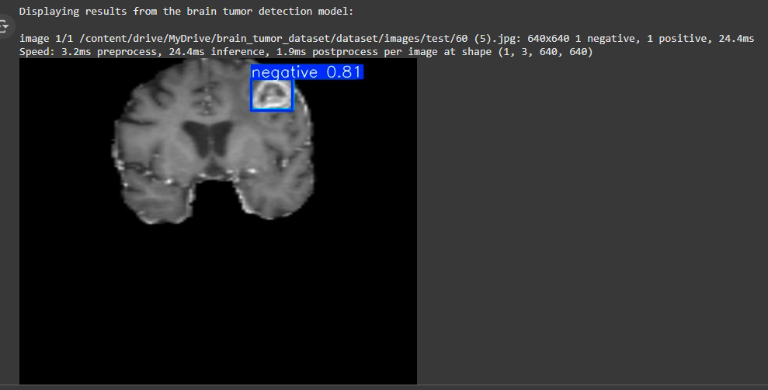
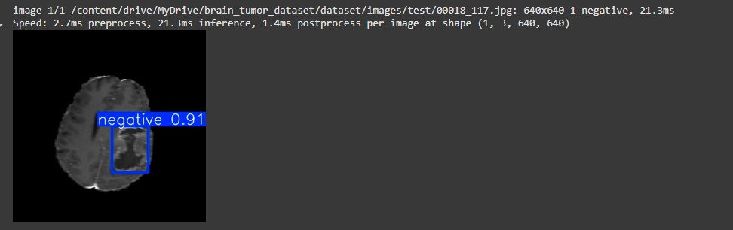
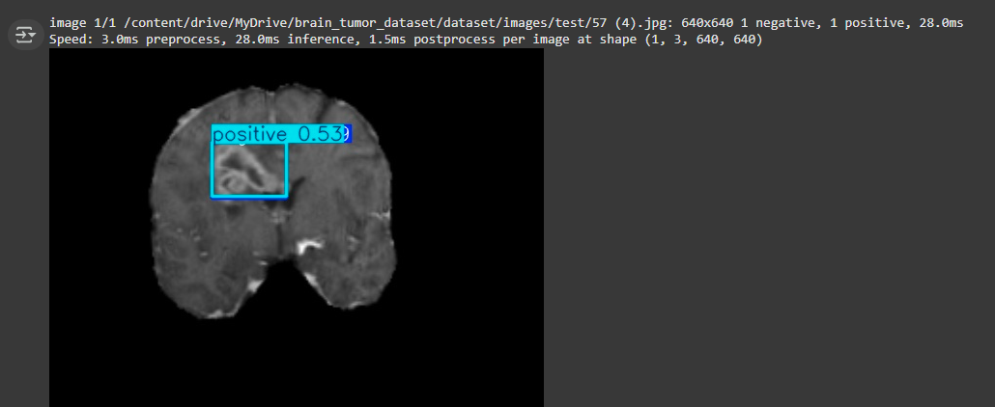
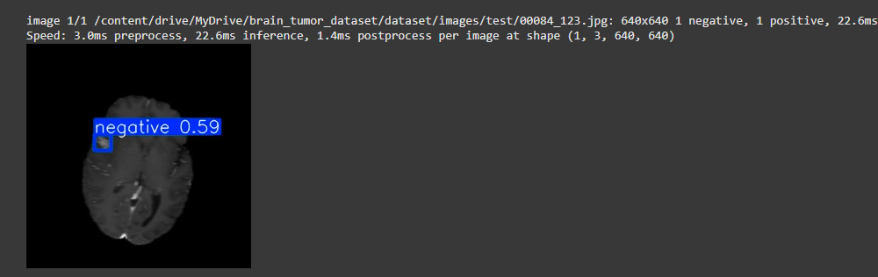
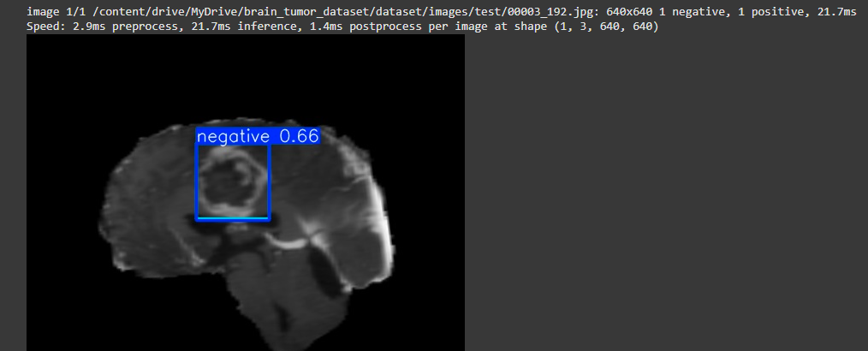
Evaluate
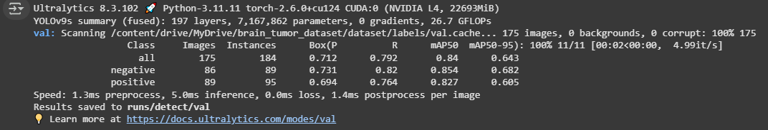

Train 50 epochs,model = yolov9s.pt ,optimizer=AdamW
Kết quả training
Ultralytics 8.3.107 🚀 Python-3.11.12 torch-2.6.0+cu124 CUDA:0 (NVIDIA A100-SXM4-40GB, 40507MiB)
engine/trainer: task=detect, mode=train, model=yolov9s.pt, data=dataset/fixed_path.yaml, epochs=50, time=None, patience=100, batch=4, imgsz=640, save=True, save_period=-1, cache=False, device=None, workers=8, project=None, name=train, exist_ok=False, pretrained=True, optimizer=AdamW, verbose=True, seed=0, deterministic=True, single_cls=False, rect=False, cos_lr=False, close_mosaic=10, resume=False, amp=True, fraction=1.0, profile=False, freeze=None, multi_scale=False, overlap_mask=True, mask_ratio=4, dropout=0.0, val=True, split=val, save_json=False, conf=None, iou=0.7, max_det=300, half=False, dnn=False, plots=True, source=None, vid_stride=1, stream_buffer=False, visualize=False, augment=False, agnostic_nms=False, classes=None, retina_masks=False, embed=None, show=False, save_frames=False, save_txt=False, save_conf=False, save_crop=False, show_labels=True, show_conf=True, show_boxes=True, line_width=None, format=torchscript, keras=False, optimize=False, int8=False, dynamic=False, simplify=True, opset=None, workspace=None, nms=False, lr0=0.01, lrf=0.01, momentum=0.937, weight_decay=0.0005, warmup_epochs=3.0, warmup_momentum=0.8, warmup_bias_lr=0.1, box=7.5, cls=0.5, dfl=1.5, pose=12.0, kobj=1.0, nbs=64, hsv_h=0.015, hsv_s=0.7, hsv_v=0.4, degrees=0.0, translate=0.1, scale=0.5, shear=0.0, perspective=0.0, flipud=0.0, fliplr=0.5, bgr=0.0, mosaic=1.0, mixup=0.0, copy_paste=0.0, copy_paste_mode=flip, auto_augment=randaugment, erasing=0.4, crop_fraction=1.0, cfg=None, tracker=botsort.yaml, save_dir=runs/detect/train
Downloading https://ultralytics.com/assets/Arial.ttf to '/root/.config/Ultralytics/Arial.ttf'...
100%|██████████| 755k/755k [00:00<00:00, 122MB/s]
Overriding model.yaml nc=80 with nc=2

from n params module arguments
0 -1 1 928 ultralytics.nn.modules.conv.Conv [3, 32, 3, 2]
1 -1 1 18560 ultralytics.nn.modules.conv.Conv [32, 64, 3, 2]
2 -1 1 31104 ultralytics.nn.modules.block.ELAN1 [64, 64, 64, 32]
3 -1 1 73984 ultralytics.nn.modules.block.AConv [64, 128]
4 -1 1 258432 ultralytics.nn.modules.block.RepNCSPELAN4 [128, 128, 128, 64, 3]
5 -1 1 221568 ultralytics.nn.modules.block.AConv [128, 192]
6 -1 1 579648 ultralytics.nn.modules.block.RepNCSPELAN4 [192, 192, 192, 96, 3]
7 -1 1 442880 ultralytics.nn.modules.block.AConv [192, 256]
8 -1 1 1028864 ultralytics.nn.modules.block.RepNCSPELAN4 [256, 256, 256, 128, 3]
9 -1 1 164608 ultralytics.nn.modules.block.SPPELAN [256, 256, 128]
10 -1 1 0 torch.nn.modules.upsampling.Upsample [None, 2, 'nearest']
11 [-1, 6] 1 0 ultralytics.nn.modules.conv.Concat [1]
12 -1 1 628800 ultralytics.nn.modules.block.RepNCSPELAN4 [448, 192, 192, 96, 3]
13 -1 1 0 torch.nn.modules.upsampling.Upsample [None, 2, 'nearest']
14 [-1, 4] 1 0 ultralytics.nn.modules.conv.Concat [1]
15 -1 1 283008 ultralytics.nn.modules.block.RepNCSPELAN4 [320, 128, 128, 64, 3]
16 -1 1 110784 ultralytics.nn.modules.block.AConv [128, 96]
17 [-1, 12] 1 0 ultralytics.nn.modules.conv.Concat [1]
18 -1 1 598080 ultralytics.nn.modules.block.RepNCSPELAN4 [288, 192, 192, 96, 3]
19 -1 1 221440 ultralytics.nn.modules.block.AConv [192, 128]
20 [-1, 9] 1 0 ultralytics.nn.modules.conv.Concat [1]
21 -1 1 1061632 ultralytics.nn.modules.block.RepNCSPELAN4 [384, 256, 256, 128, 3]
22 [15, 18, 21] 1 1563862 ultralytics.nn.modules.head.Detect [2, [128, 192, 256]]
YOLOv9s summary: 544 layers, 7,288,182 parameters, 7,288,166 gradients, 27.4 GFLOPs

Transferred 1333/1339 items from pretrained weights
TensorBoard: Start with 'tensorboard --logdir runs/detect/train', view at http://localhost:6006/
Freezing layer 'model.22.dfl.conv.weight'
AMP: running Automatic Mixed Precision (AMP) checks...
AMP: checks passed ✅
train: Scanning /content/drive/MyDrive/brain_tumor_dataset/dataset/labels/train... 451 images, 0 backgrounds, 0 corrupt: 100%|██████████| 451/451 [00:40<00:00, 11.10it/s]
train: New cache created: /content/drive/MyDrive/brain_tumor_dataset/dataset/labels/train.cache
albumentations: Blur(p=0.01, blur_limit=(3, 7)), MedianBlur(p=0.01, blur_limit=(3, 7)), ToGray(p=0.01, num_output_channels=3, method='weighted_average'), CLAHE(p=0.01, clip_limit=(1.0, 4.0), tile_grid_size=(8, 8))
val: Scanning /content/drive/MyDrive/brain_tumor_dataset/dataset/labels/val... 427 images, 0 backgrounds, 0 corrupt: 100%|██████████| 427/427 [00:45<00:00, 9.34it/s]
val: New cache created: /content/drive/MyDrive/brain_tumor_dataset/dataset/labels/val.cache
Plotting labels to runs/detect/train/labels.jpg...
optimizer: AdamW(lr=0.01, momentum=0.937) with parameter groups 221 weight(decay=0.0), 228 weight(decay=0.0005), 227 bias(decay=0.0)
TensorBoard: model graph visualization added ✅
Image sizes 640 train, 640 val
Using 8 dataloader workers
Logging results to runs/detect/train
Starting training for 50 epochs...

50 epochs completed in 0.368 hours.
Optimizer stripped from runs/detect/train/weights/last.pt, 15.2MB
Optimizer stripped from runs/detect/train/weights/best.pt, 15.2MB

Validating runs/detect/train/weights/best.pt...
Ultralytics 8.3.107 🚀 Python-3.11.12 torch-2.6.0+cu124 CUDA:0 (NVIDIA A100-SXM4-40GB, 40507MiB)
YOLOv9s summary (fused): 197 layers, 7,167,862 parameters, 0 gradients, 26.7 GFLOPs
Class Images Instances Box(P R mAP50 mAP50-95): 100%|██████████| 54/54 [00:03<00:00, 16.15it/s]
all 427 453 0.478 0.868 0.519 0.373
negative 208 218 0.469 0.872 0.513 0.372
positive 219 235 0.487 0.864 0.525 0.374
Speed: 0.1ms preprocess, 3.6ms inference, 0.0ms loss, 0.9ms postprocess per image
Results saved to runs/detect/train
Ultralytics 8.3.107 🚀 Python-3.11.12 torch-2.6.0+cu124 CUDA:0 (NVIDIA A100-SXM4-40GB, 40507MiB)
YOLOv9s summary (fused): 197 layers, 7,167,862 parameters, 0 gradients, 26.7 GFLOPs
val: Scanning /content/drive/MyDrive/brain_tumor_dataset/dataset/labels/val.cache... 427 images, 0 backgrounds, 0 corrupt: 100% 427/427 [00:00<?, ?it/s]
Class Images Instances Box(P R mAP50 mAP50-95): 100% 27/27 [00:03<00:00, 7.28it/s]
all 427 453 0.476 0.865 0.519 0.375
negative 208 218 0.468 0.872 0.513 0.374
positive 219 235 0.485 0.858 0.526 0.375
Speed: 0.6ms preprocess, 2.5ms inference, 0.0ms loss, 1.4ms postprocess per image
Results saved to runs/detect/val2
